# Procedure CDP07- Business Analysis

# Functional Requirements

Functional requirements of a system show the actual functions and components of the system. As the system has a website and a mobile application, and both have different functional requirements, the following list shows functional requirements of the system

## Application’s Functional Requirements:

* Employee Login to the application
* Register a new employee
* View home page of the application
* View assigned tasks
* View pending tasks
* Mark a pending task as completed
* Send feedback of the task
* View completed tasks
* Send current location
* View location details
* Logout

## Website’s Functional Requirements:

* Admin login to the system
* View dashboard of the website
* View all employees on a map on dashboard
* View all employees list
* Add, update and delete any employee
* View pending employees’ registration
* Assign a new task to an employee
* View completed tasks
* View all system admins
* Add, update or delete an admin of the system

## Non-Functional Requirements:

### Safety and security Requirements:

As it is a web and android based system, and the database would be central, high security would be required. Locations and tasks data should be secured. Only authorized users must be accessing the data.

### Availability:

The system should be available 24/7 to the admin and employees.

### Correctness:

The automated operations and data accuracy should be correct, specifically the location coordinates.

### Usability:

The system should satisfy the maximum number of clients

### Portable:

The system should be portable in any kind of android phone and any kind of browser.

# Use Case diagram:

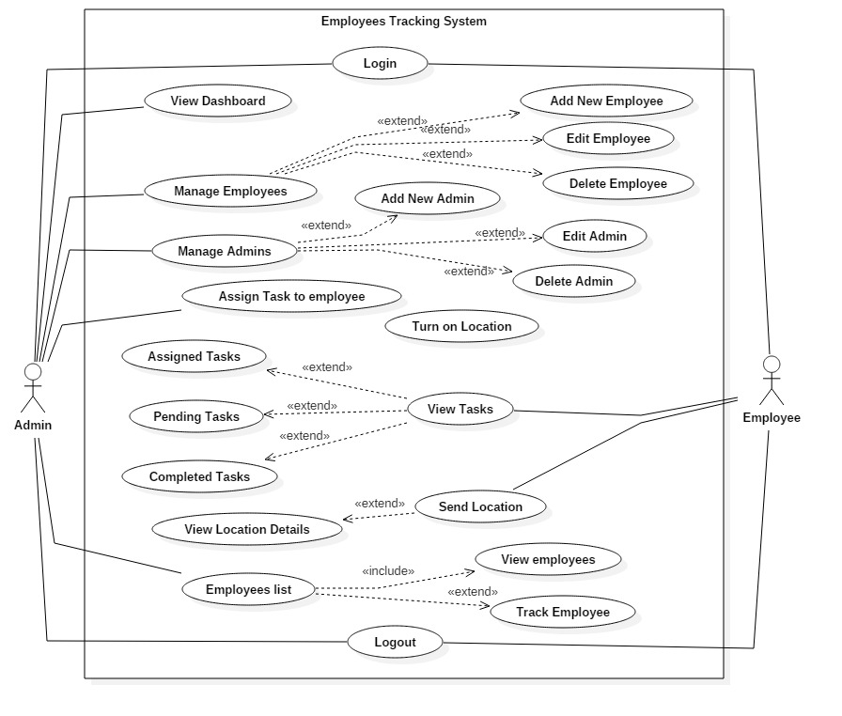

*Use Case Diagram*

# Scoping:

After a complete discussion with the project manager and the software engineers, proper scope and boundary lines were defined for the project. The main scope of the system is that it would have an android application and a website. The employees would be able to access their account in mobile application while the admin will access through the website. The clear boundaries of the admin website would be the following:

* Login to the system through the given email and password
* View dashboard on the main page
* View all the locations of employees on the main dashboard
* Add new employees, update and delete employees
* Approve the pending employees that needs to sign up
* Assign a task to the employee
* View pending tasks
* View pending employees
* View completed tasks
* View his profile
* Log out of the system

The clear boundaries of the mobile application would be:

* Sign up to the application
* Login to the application
* View tasks assigned to him
* Mark a task completed
* Send remarks on that task to the admin
* View pending tasks
* View all his completed tasks
* Send location to the admin
* Log out of the application

These are the fixed main functionalities of the system that must b implemented in both mobile application and website.

# Future improvements:

Any system can have gaps for improvements. When a system is developed for the first time, it is presented for different kinds of testing techniques to check if there is any gap of improvement or not. We also had a lot of work to add to the system but we left that for future improvements.

Some of the future improvements are:

* Attendance system in the application
* Integration of mobile phone fingerprint
* Phone calls integration
* SMS integration
* Emails integration
* All these integrations would be for any new task or completing a task or any other notification
* Admin chat with the employee
* Reports generation
* All employees’ monthly reports to the admin
* Monthly report to the employee
* Graphs to show employees’ performance to the admin

# References:

1. <https://pk.zapmeta.ws/ws?q=employee%20tracking%20system&asid=zm_pk_gb_1_cg1_00&mt=b&nw=g&de=c&ap=&ac=469&cid=7179825043&aid=85650211332&kid=kwd-15708233&locale=en_PK&gclid=EAIaIQobChMIp7iksI3d8AIVFWgYCh0FCwq8EAAYBCAAEgIiEfD_BwE>
2. <https://www.activtrak.com/employee-monitoring/>
3. <https://www.researchgate.net/publication/310761520_An_Android_based_Employee_Tracking_System>
4. <https://www.academia.edu/24591619/EMPLOYEE_TRACKING_SYSTEM>
5. <https://www.researchgate.net/publication/310761520_An_Android_based_Employee_Tracking_System>

# Functional Testing

After development, the project was presented for functional testing. Functional testing means to test all the functionalities that were defined by the business analyst. To check whether all the functional requirements are working completely or not.

## Website Functional Testing:

Following are the test cases written for the functional testing of website:

|  |  |  |  |  |
| --- | --- | --- | --- | --- |
| Test Case | Description | User Action | Response of the system | Implemented 100% |
| 1 | Admin login | User provides the login credentials and clicks on the login button | System shows a success message and logins admin if the credentials are correct | Yes |
| 2 | View dashboard | User clicks on the login button or if already logged in, then clicks on the dashboard button in the sidebar | System logins and load the main dashboard page of the website | Yes |
| 3 | All employees on the map | User clicks on the dashboard button in the side bar | System loads the dashboard and shows the employees on the map, with red location spots | Yes |
| 4 | View all employee’s list | User clicks on the employees’ option in the side bar | System load the employees list page and shows all the employees in a list | Yes |
| 5 | Add an employee | User clicks on the add new employee button, system loads the form, user fills the required fields and clicks on the add employee button | System adds the employee and shows a success message if all the form fields are filled correctly. | Yes |
| 6 | Edit an employee | Use clicks on the edit employee button, system loads the edit employee form, user makes the changes and clicks on the edit employee button | System updates the employee info and prints a success message | Yes |
| 7 | Delete an employee | User clicks on the delete button in front of any employee in the employees’ list | System deletes the specific employee and shows a success message | Yes |
| 8 | View pending employees | User clicks on the pending employees in the side bar | System shows all the pending employees | Yes |
| 9 | Approve an employee | User clicks on the approve button for any employee | System approves the signup of that specific employee. | Yes |
| 10 | Assign a task to an employee | User clicks on the assign new task option in the sidebar, system loads a form, admin fills it and click on the assign task button | System assign the task to that employee and shows a success message | Yes |
| 11 | View completed tasks | User clicks on the completed tasks option in the sidebar | System loads all the completed tasks | Yes |
| 12 | View system admins | User clicks on the view users’ option in the side bar | System loads all the system admins | Yes |
| 13 | Add a new admin to the system | User clicks on the add new admin button, system loads the form, user fills the required fields and clicks on the add admin button | System adds the admin to the system and shows a success message if all the form fields are filled correctly. | Yes |
| 14 | Update the admin info | Use clicks on the edit user button, system loads the edit user form, user makes the changes and clicks on the edit user button | System updates the admin info and prints a success message | Yes |
| 15 | Delete an admin | User clicks on the delete button in front of any admin/User in the users’ list | System deletes the specific user and shows a success message | Yes |

## Application Functional Testing:

Following are the test cases for the functional testing of the application:

|  |  |  |  |  |
| --- | --- | --- | --- | --- |
| Test Case | Description | User Action | System Response | Implemented 100% |
| 1 | Register a new Employee | User clicks on the register now button, System loads the employee registration form. User fills it correctly and clicks on the register button | System sends its approval to the admin website and prints a success message | Yes |
| 2 | Login to the application | User provides the login credentials and clicks on the login button | System checks the credentials, if correct, logs in the user to the system | Yes |
| 3 | View Home Page | User clicks on the login button | If the user is already approved by the admin, the system loads home page of the application | Yes |
| 4 | View Assigned Tasks | User clicks on the View Assigned tasks option on the home page | System prints all the tasks assigned by the admin to the employee | Yes |
| 5 | View Pending Tasks | User clicks on the View Pending tasks option on the home page | System prints all the pending tasks to the employee | Yes |
| 6 | Mark a pending task completed | User clicks on the mark as completed button | Application marks that task as completed and send it to the admin | Yes |
| 7 | Send remarks of the task | User fills the remarks field and click on the send remarks button | Application sends the remarks to the admin | Yes |
| 8 | View Completed tasks | User clicks on the Completed tasks option on the home page | Application shows all the completed tasks to the user | Yes |
| 9 | Send Current Location | User clicks on the Send location option on the home page | Application shows the current location details | Yes |
| 10 | View Location Details | User views the current location details and clicks on the send location button | Application send that location to the system | Yes |
| 11 | Log out of the system | User clicks on the log out button | Application logs the user out of the sysstem | Yes |